Oriental Pearl Tower

The **Oriental Pearl Radio & Television Tower** ([simplified Chinese](https://en.wikipedia.org/wiki/Simplified_Chinese_characters): 东方明珠塔; [traditional Chinese](https://en.wikipedia.org/wiki/Traditional_Chinese_characters): 東方明珠塔; [pinyin](https://en.wikipedia.org/wiki/Pinyin): *Dōngfāng Míngzhūtǎ;*[*Shanghainese*](https://en.wikipedia.org/wiki/Shanghainese)*: Tonfån Mintsythah*, official name: 东方明珠广播电视塔) is a [TV tower](https://en.wikipedia.org/wiki/TV_tower) in [Shanghai](https://en.wikipedia.org/wiki/Shanghai). Its location at the tip of [Lujiazui](https://en.wikipedia.org/wiki/Lujiazui" \o "Lujiazui) in the [Pudong New Area](https://en.wikipedia.org/wiki/Pudong_New_Area" \o "Pudong New Area) by the side of [Huangpu River](https://en.wikipedia.org/wiki/Huangpu_River), opposite [The Bund](https://en.wikipedia.org/wiki/The_Bund_(Shanghai)), makes it a distinct landmark in the area. Its principal designers were Jiang Huan Chen, Lin Benlin, and Zhang Xiulin. Construction began in 1991, and the tower was completed in 1994.

At 468 m (1,536 feet) high, it was the [tallest structure in China](https://en.wikipedia.org/wiki/List_of_tallest_structures_in_China) from 1994–2007, when it was surpassed by the [Shanghai World Financial Center](https://en.wikipedia.org/wiki/Shanghai_World_Financial_Center). It is classified as an [AAAAA scenic area](https://en.wikipedia.org/wiki/AAAAA_scenic_area" \o "AAAAA scenic area) by the [China National Tourism Administration](https://en.wikipedia.org/wiki/China_National_Tourism_Administration).[[5]](https://en.wikipedia.org/wiki/Oriental_Pearl_Tower#cite_note-5) The tower is brightly lit in different [LED](https://en.wikipedia.org/wiki/LED) sequences at night. On 7 July 2007, Oriental Pearl Tower was host to the [Chinese Live Earth concert](https://en.wikipedia.org/wiki/Live_Earth_concert,_Shanghai).

The tower features 11 spheres, big and small. The two largest spheres, along the length of the tower, have diameters of 50 m (164 ft) for the lower and 45 m (148 ft) for the upper. They are linked by three columns, each 9 m (30 ft) in diameter. The highest sphere is 14 m (46 ft) in diameter.

In 1995, the Oriental Pearl TV Tower was rated as one of the top ten new landscapes in Shanghai. In 1999, the Oriental Pearl TV Tower won the first prize of Shanghai Excellent Survey and Design Award and the Zhan Tianyou Award of China Civil Engineering. On May 8, 2007, the Oriental Pearl TV Tower was approved by the National Tourism Administration as a national AAAAA-level tourist attraction.

The entire tower is supported by three enormous [columns](https://en.wikipedia.org/wiki/Column) that start underground.

Observation levels[[edit](https://en.wikipedia.org/w/index.php?title=Oriental_Pearl_Tower&action=edit&section=1" \o "Edit section: Observation levels)]

The tower has fifteen observatory levels. The highest (known as the Space Module) is at 351 m (1148 ft). The lower levels are at 263 m (863 ft) (Sightseeing Floor) and at 90 m (295 ft) (Space City). There is a [revolving restaurant](https://en.wikipedia.org/wiki/Revolving_restaurant) at the 267 m (876 ft) level. The project also contains exhibition facilities and a small shopping center. There is also a 20-room hotel called the Space Hotel between the two large spheres. The upper observation platform has an outside area with a 1.5 inch glass floor.[[6]](https://en.wikipedia.org/wiki/Oriental_Pearl_Tower#cite_note-6)

Antenna spire[[edit](https://en.wikipedia.org/w/index.php?title=Oriental_Pearl_Tower&action=edit&section=2" \o "Edit section: Antenna spire)]

An [antenna](https://en.wikipedia.org/wiki/Antenna_(radio)), broadcasting TV and radio programs, extends the construction by another 118 m (387 ft) to a total height of 468 m (1,535 ft).

Chinese symbolism in the design[[edit](https://en.wikipedia.org/w/index.php?title=Oriental_Pearl_Tower&action=edit&section=3" \o "Edit section: Chinese symbolism in the design)]

The chief of the jury board said[[7]](https://en.wikipedia.org/wiki/Oriental_Pearl_Tower#cite_note-7) that the design reminded him of a verse of the [Tang Dynasty](https://en.wikipedia.org/wiki/Tang_Dynasty) poem ["Pipa Song"](https://en.wikipedia.org/wiki/Pipa_xing) by [Bai Juyi](https://en.wikipedia.org/wiki/Bai_Juyi) about the wonderful sprinkling sound of a [pipa](https://en.wikipedia.org/wiki/Pipa" \o "Pipa) instrument, like [pearls](https://en.wikipedia.org/wiki/Pearl), big and small falling on a [jade](https://en.wikipedia.org/wiki/Jade) plate (大珠小珠落玉盘/大珠小珠落玉盤/dà zhū xiǎo zhū luò yù pán). However, the designer Jiang Huancheng says that he did not have the poem in mind when designing the tower.

2010 fire[[edit](https://en.wikipedia.org/w/index.php?title=Oriental_Pearl_Tower&action=edit&section=4" \o "Edit section: 2010 fire)]

On 13 April 2010 the antenna at the top of tower caught fire at around 02:00. The fire was then put out by firefighters. No casualties were reported. Prior to the fire there was a series of thunderstorms.[[8]](https://en.wikipedia.org/wiki/Oriental_Pearl_Tower#cite_note-8)[[9]](https://en.wikipedia.org/wiki/Oriental_Pearl_Tower#cite_note-9)

Interesting facts about the Oriental Pearl Tower

The **Oriental Pearl Radio & Television Tower** is a TV tower in [Shanghai](http://justfunfacts.com/interesting-facts-about-shanghai/).

It is commonly known as **Oriental Pearl Tower**.

The tower is **located** in Pudong Park in Lujiazui, Shanghai.

**Construction** **began in** **1991**, and the tower was **completed in** **1994**.

The Oriental Pearl Tower is the **world’s sixth tallest TV and radio tower.**

[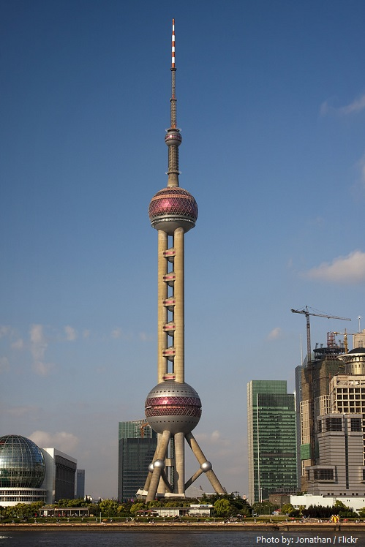](http://justfunfacts.com/wp-content/uploads/2019/01/oriental-pearl-tower-2.jpg)

It was was the **tallest building in China from 1994 to 2007** when it was surpassed by the Shanghai World Financial Center.

**Total height** of tower from base including antenna, **468 meters** (1,535 feet).

The tower features **11 spheres**, big and small.

There are **3 large spheres** including the top sphere, known as the space module.

The **two largest spheres**, along the length of the tower, have **diameters of** **50 meters** (164 ft) **for the lower** and **45 meters** (148 ft) **for the upper**. The **space module sphere** is **14 meters** (46 ft) **in diameter**.

[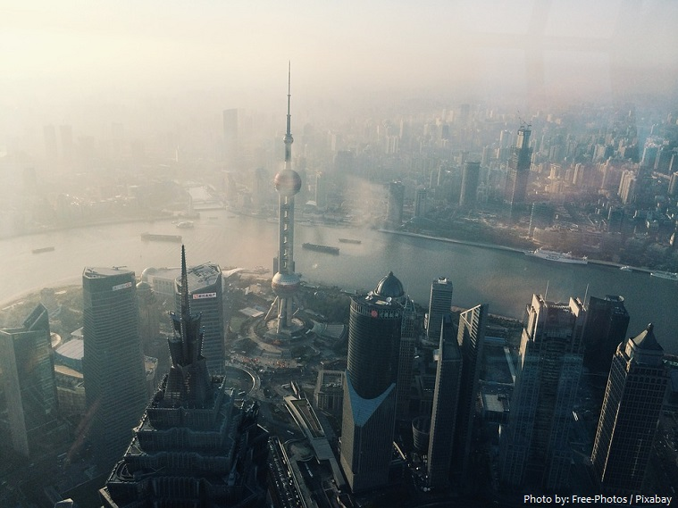](http://justfunfacts.com/wp-content/uploads/2019/01/oriental-pearl-tower-3.jpg)

The **largest sphere** is linked by **three columns**, each **9 meters** (30 ft) **in diameter**.

Then there are **5 smaller spheres** and **3 decorative spheres** on the base.

The entire structure rests on rich green [grassland](http://justfunfacts.com/interesting-facts-about-the-grassland/) and gives the appearance of [pearls](http://justfunfacts.com/interesting-facts-about-pearls/) shining on a [jade](http://justfunfacts.com/interesting-facts-about-jade/) plate.

The tower has **fifteen observatory levels**. The highest is the **space module** is at **351 meters** (1,148 ft). The **lower levels** are at **263 meters** (863 ft) and at **90 meters** (295 ft).

There is a **revolving restaurant** at the **267 meters** (876 ft) **level**.

The tower also contains **exhibition facilities** and a **small shopping center**.

There is also a **20-room hotel** called the **Space Hotel** between the two large spheres

Visitors travel up and down the Oriental Pearl Tower in **double-decker elevators** that can hold up to 50 people at the rate of 7 meters per second.

The Oriental Pearl Tower is **brightly lit in different LED sequences at night**.

An **antenna**, broadcasting TV and radio programs is **118 meters** (387 ft) **high**.The tower is supposed to make the viewer think that **pearls are dropping onto an jade plate**. The **entire scene is a photographic jewel** that excites the imagination and attracts thousands of visitors year-round

|  |  |
| --- | --- |
| **Oriental Pearl Radio & TV Tower** | |
| 东方明珠广播电视塔 | |
| [Oriental Pearl Tower in Shanghai.jpg](https://en.wikipedia.org/wiki/File:Oriental_Pearl_Tower_in_Shanghai.jpg)  The Oriental Pearl Tower in December 2014 | |
| [[https://maps.wikimedia.org/img/osm-intl,13,31.241669,121.494717,250x200.png?lang=en&domain=en.wikipedia.org&title=Oriental+Pearl+Tower&groups=_3dece4ca90985bb678e3f22f0bfadf2c40021ad9](https://en.wikipedia.org/wiki/Oriental_Pearl_Tower#/map/0)](https://en.wikipedia.org/wiki/Oriental_Pearl_Tower" \l "/map/0)  [Wikimedia](https://foundation.wikimedia.org/wiki/Maps_Terms_of_Use) | © [OpenStreetMap](https://www.openstreetmap.org/copyright) | |
| **General information** | |
| **Type** | Communication, hotel, observation, restaurant |
| **Location** | [Shanghai](https://en.wikipedia.org/wiki/Shanghai) |
| [**Coordinates**](https://en.wikipedia.org/wiki/Geographic_coordinate_system) | https://upload.wikimedia.org/wikipedia/commons/thumb/5/55/WMA_button2b.png/17px-WMA_button2b.png[31°14′30″N 121°29′41″E](https://geohack.toolforge.org/geohack.php?pagename=Oriental_Pearl_Tower&params=31.241669_N_121.494717_E_type:landmark_region:CN-SH)[Coordinates](https://en.wikipedia.org/wiki/Geographic_coordinate_system): https://upload.wikimedia.org/wikipedia/commons/thumb/5/55/WMA_button2b.png/17px-WMA_button2b.png[31°14′30″N 121°29′41″E](https://geohack.toolforge.org/geohack.php?pagename=Oriental_Pearl_Tower&params=31.241669_N_121.494717_E_type:landmark_region:CN-SH) |
| **Construction started** | 30 July 1991[[1]](https://en.wikipedia.org/wiki/Oriental_Pearl_Tower#cite_note-1) |
| **Completed** | 1994[[2]](https://en.wikipedia.org/wiki/Oriental_Pearl_Tower#cite_note-2) |
| **Height** | |
| **Antenna spire** | 467.9 m (1,535 ft) |
| **Top floor** | 351.0 m (1,152 ft) |
| **Technical details** | |
| **Floor count** | Equivalent of a 153 story building |
| **Lifts/elevators** | 6 |
| **Design and construction** | |
| **Architect** | Shanghai Modern Architectural Design Co. Ltd. |
| **Developer** | [Shanghai Oriental Group Co. Ltd.](https://en.wikipedia.org/wiki/Shanghai_Oriental_Pearl_Media) |
| **References** | |
| [[3]](https://en.wikipedia.org/wiki/Oriental_Pearl_Tower#cite_note-3)[[4]](https://en.wikipedia.org/wiki/Oriental_Pearl_Tower#cite_note-4) | |